**Bi-Weekly Report of (Team#10 ) Week #6**

**What were the goals for the last 2 weeks?**

* Unreal Engine 5 environment settings & Learning
* **[All members]:** Install Unreal Engine 5 and set the user environment. Getting familiar with UE5 and finishing lecture and tutorial series by making example projects.
* Polish MiniGame A(Card game) Flow & Mechanism
* **[MinSeop Lee & SeungHwan Yang]:** Finalize mechanisms & gameplay flow of MiniGame A. A flow must be sophisticated enough to implement in a code.
* Decide which 3D assets to use
* **[Yiel Jang]:** Find and decide which 3D models to use in the game project.
* Version Control & Coop tool settings
* **[JongEun Park]:** Decide which version control & coop tools to use in the project & set the user environment.
* Basic Network Environment Settings (barebone)
* **[Yiel Jang & other available members]:** Implement a barebone network multiplayer environment where users can access a single world in the remote game server.
* Modular level layout Design
* **[Yiel Jang]:** Make a rough sketch of a world concept with a modular level design method.

**What goals were accomplished this week?**

* Unreal Engine 5 Environment Settings & Learning
* **[All members]:** Successfully finished setting the UE5 environment on each machine. Additionally, completed parts of an advanced tutorial on UE5's visual scripting system, Blueprints, which will enable us to implement complex game mechanics more efficiently.
* Polish MiniGame A (Card Game) Flow & Mechanism + World design

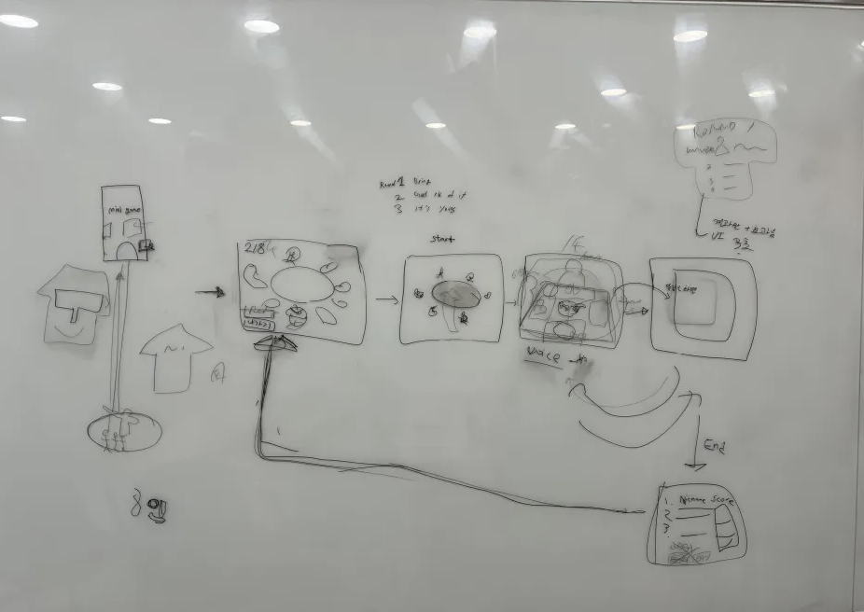

Sketch on gameplay flow of MiniGame A, with simple world design

* **[Min Seop Lee & SeungHwan Yang]:** Refined and finalized the gameplay mechanics and flow for MiniGame A, ensuring a smooth and engaging player experience. This included optimizing card draw algorithms and enhancing UI interactions for better gameplay clarity.

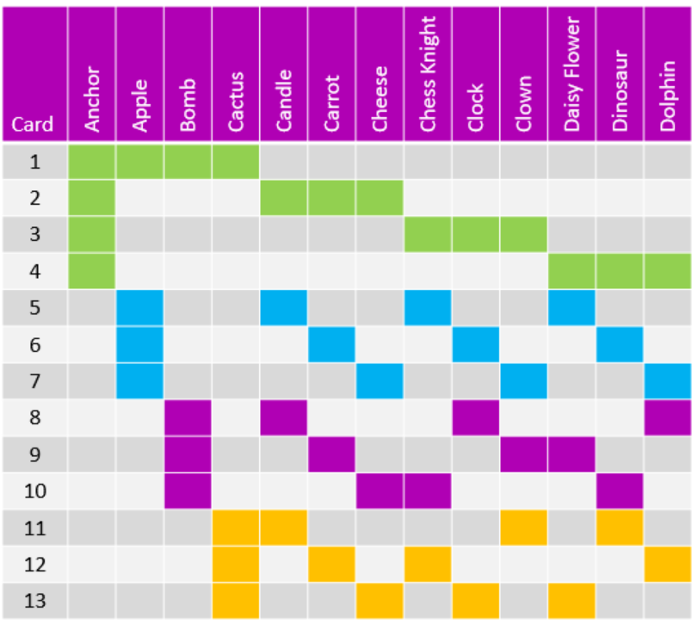

Chart on symbol matching state in a gameplay

* **[SeungHwan Yang]:** leverages the geometric structure of the finite projective plane, adding layers of strategic depth to the game introducing varied symbolic connections and effects, thus ensuring that the "bring it, get rid of it, it’s yours" gameplay remains engaging across multiple rounds.
* Decide Which 3D Assets to Use
* **[Yiel Jang]**: Completed a review of available 3D assets and made selections on the assets to incorporate into our game environment and character designs. This process involved evaluating asset compatibility with our game's aesthetic and technical requirements.

<https://kaylousberg.itch.io/prototype-bits>

* Version Control & Collaboration Tool settings
* **[Jongeun Park]:** Successfully set up and configured our version control system using Perforce + AWS, integrating it with UE5 to streamline our workflow. Established a cooperative working environment through effective use of collaboration tools, ensuring seamless communication and task tracking among team members.

**Reflect critically on any goals not accomplished.**

* Lack of progress in learning Unreal Engine 5
* **[All members]:** We didn’t fully go through the lessons and materials we had planned to go through individually. We plan to supplement our learning in the following weeks.
* Basic Network Environment Settings (barebone)
* **[Yiel Jang & other available members]:** The reason mentioned above limited the time we had to learn about the network setup, which directly slowed down our progress in getting the network setup done.

**What are the goals for next two weeks?**

* Learning UE5
* **[All members]:** Continue learning UE5 with lectures and tutorials. ex) casting & actor attachment, adding and removing tags, Tarray,
* Basic Network Environment Settings (barebone)
* **[Yiel Jang]:** Implement a barebone network multiplayer environment where users can access a single world in the remote game server.
* Modular level layout Design -> World design
* **[Jongeun Park]**: Make a rough sketch of a world concept with a modular level design method.
* Polish MiniGame B(Pixel puzzle game) Flow & Mechanism
* **[Minseop Lee + others]:** Finalize mechanisms & gameplay flow of MiniGame B. A flow must be sophisticated enough to implement in a code. Should decide how to approach the z-axis variance of cube size when players are moving around.
* Design UI & outlining Sound design.
* **[All members]:** Will be discussed in a separate group meeting session.

**How many hours were spent on each goal noted above?**

* Unreal Engine 5 tutorial courses + environment settings **[All members]**
  1. Warehouse Wreckage(3hr 30min): Physics simulation, Actor spawning, Brining asset, etc
  2. Obstacle Assault(5hr 30min): Compiler and editor, Basis technology of C++ in engine, FRotator, etc
  3. Crypt Raider (7hr 30min): Module level design, character blueprint, mapping, sweeping ,etc
* Polish MiniGame A(Card game) Flow & Mechanism:
  1. **[Min Seop Lee & SeungHwan Yang]:** 
     1. Finalized gameplay mechanics and flow for MiniGame A(1hr 30min)
     2. Optimized card draw algorithms(1hr 30min)
     3. Enhanced UI interactions for clarity(1hr)
  2. **[SeungHwan Yang]**
     1. Enhanced depth with geometric structure(1hr)
     2. Added symbolic effects for engagement(1hr)
     3. Maintained dynamic gameplay loop(1hr)

* Decide which 3D assets to use
  1. **[Yiel Jang]**:
     1. Reviewed 3D assets, selecting suitable ones(3hr +)
     2. Ensured compatibility with game aesthetic and tech needs
* Version Control & Collaboration tool settings
  1. **[Jongeun Park]:**
     1. Established Perforce version control system(5hr +)
     2. Integrated with development tools
     3. Fostered cooperative environment with collaboration tool